Ohio Northern University

Interfraternity Council General Assembly Agenda

Date: 9/18/2019 Time: 5:30 P.M. - 6:00 P.M.

Call To Order

Roll Call
- Alpha Sigma Phi (ΑΣΦ) - Present
- Delta Sigma Phi (ΔΣΦ) - Present
- Phi Gamma Delta (FIJI) - Present
- Phi Mu Delta (ΦΜΔ) - Present
- Sigma Phi Epsilon (ΣΦΕ) - Present
- Sigma Pi (ΣΠ) - Present
- Theta Chi (ϴΧ) - Present

Approval of the Previous Minutes:
Motioned: ΔΣΦ
Seconded: ΑΣΦ

Officer Reports
- President: (Alex Nixon)
  - We are voting on what was discussed last week
  - “Escorts” for bid distribution
    - Alpha Sigma Phi (ΑΣΦ) - Ben
    - Delta Sigma Phi (ΔΣΦ) - Joe
    - Phi Gamma Delta (FIJI) - Josh
    - Phi Mu Delta (ΦΜΔ) - Brian
    - Sigma Phi Epsilon (ΣΦΕ) - Avery
    - Sigma Pi (ΣΠ) - Trevor
    - Theta Chi (ϴΧ) - Alex
  - We mentioned discounts on dues
    - Gold $5
    - Silver $3
    - Bronze $1
- Vice President of Administration and Public Relations: (Trevor Rice)
  - Anybody have a graphic design major in their chapter
  - Next week I am going to send out Greek Man of the Month forms for each chapter
    - Ian Wesley form Theta Chi? i-wesley.1@onu.edu
- Vice President of Leadership Development (Brian Pencil)
  - Leadership Day has been moved to Dec. 7
    - The weekend before Dead Week
- Vice President of Recruitment: (Joe Slusher)
  - Bid handouts Friday at mac fountains @6pm
- Vice President of Risk Management: (Josh Svihovec)
  - Risk event with fearless shenanigans on Tuesday, October 8th 5-6.
- Vice President of Finance: (Ben Hood)
- Check to NIC - $210
- Check to ONU for greek cookout - $435.90
- Vice President of Campus and Interfraternal Relations: (Avery Meadows)
  - Working with Theta Chi for a fraternity hang out soon
  - Keep planning socials/joint service events with each other, it’s good to see

Advisor Report:(Jacob Isaacson)

Old Business:
- 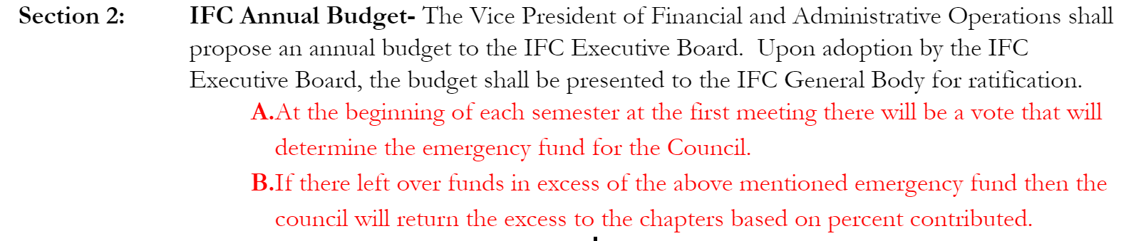
- Motioned:
- Seconded:
  - For: Everyone
  - Against:
  - Abstentions:
New Business:
- Recruitment policy
  - Old/stupid: At least 24 hours must be given to bid recipients make a decision on accepting their bid, during which, no recruitment events can be held.
  - Revised: Bids cannot be signed until the following morning at eight am to allow for people to make a decision on accepting their bid, during which, no recruitment events can be held.
- Recruitment length/the season
Chapter Reports:
- Alpha Sigma Phi (ΑΣΦ)
  - Have a solid group of PNMs
  - Pump and Run event with PolarFit is Sunday (9/22)
    - https://docs.google.com/forms/d/e/1FAIpQLScV9KnYyZe0_540qImhOeuLd5p0eraNffr5ko-QxogO7Iuvnw/viewform?usp=pp_url
  - Chartering Ceremony - October 5th
  - Volley for the Minds tournament in November
  - Brother Retreat - weekend of October 12th (Fall Break)
  - HC Sign Ups
    - https://docs.google.com/forms/d/e/1FAIpQLSd9cA1E0G8D5e8ohKvOIKiwzrBNrgQFXrmpre9ro5vtkg7RQQ/viewform?usp=pp_url

- Delta Sigma Phi (ΔΣΦ)
  - Hog roast went well
  - We are closing out the rush season handing out a total of 14 bids
  - Preparing for homecoming
  - Philanthropy and socials coming around halloween

- Phi Gamma Delta (FIJI)
  - Phi Gamma Melta is the 25th
    - We have a flyer for that I can share
  - Elected IFC J board - Jackson Austin
  - Tailgate social with ZTA and PMD the 28th
  - SAFTGB is the Oct. 19
- Phi Mu Delta (ΦΜΔ)
  - Excited to hand out bids, we have a great group of PNMs
  - Service event last weekend was a huge success- we plan on doing more this semester
  - Planning a social with FIJI and Zeta Tau Alpha on the 28th
  - Picking an IFC J board rep at next chapter
- Sigma Phi Epsilon (ΣΦΕ)
  - Very excited to hand out bids
  - Milkshakes fundraiser was yesterday. Thanks to everyone who came by.
  - Have our first official programming event next week so events will be coming soon
- Sigma Pi (ΣΠ)
  - Looking forward to bid day
  - In the process of planning socials with the Zetas and the Delts
  - Bowling this Friday
- Theta Chi (ϴΧ)
  - Service event planned with Alpha Xi
  - Good rush season

Closing Remarks:
Go bears-ΔΣΦ
Adjournment:
Motioned: ΔΣΦ
Seconded: ΑΣΦ

