Ohio Northern University

Interfraternity Council General Assembly Agenda

Date:11/13/19 Time: 5:30 P.M. - 6:00 P.M.

Call To Order

Roll Call
- Alpha Sigma Phi (ΑΣΦ) - Present
- Delta Sigma Phi (ΔΣΦ) - Present
- Phi Gamma Delta (FIJI) - Present
- Phi Mu Delta (ΦΜΔ) - Present
- Sigma Phi Epsilon (ΣΦΕ) - Present
- Sigma Pi (ΣΠ) - Present
- Theta Chi (ϴΧ) - Present

Approval of the Previous Minutes:
Motioned: ΑΣΦ
Seconded: ΦΜΔ

Officer Reports
- President: (Alex Nixon)
  - Interviews for candidates is next Wednesday from 5-9 pm
  - WE NEED A SANTA
  - Voting on the new bylaw
- Vice President of Administration and Public Relations: (Trevor Rice)
  - Congratulations to Jared Cottingim of FIJI
  - 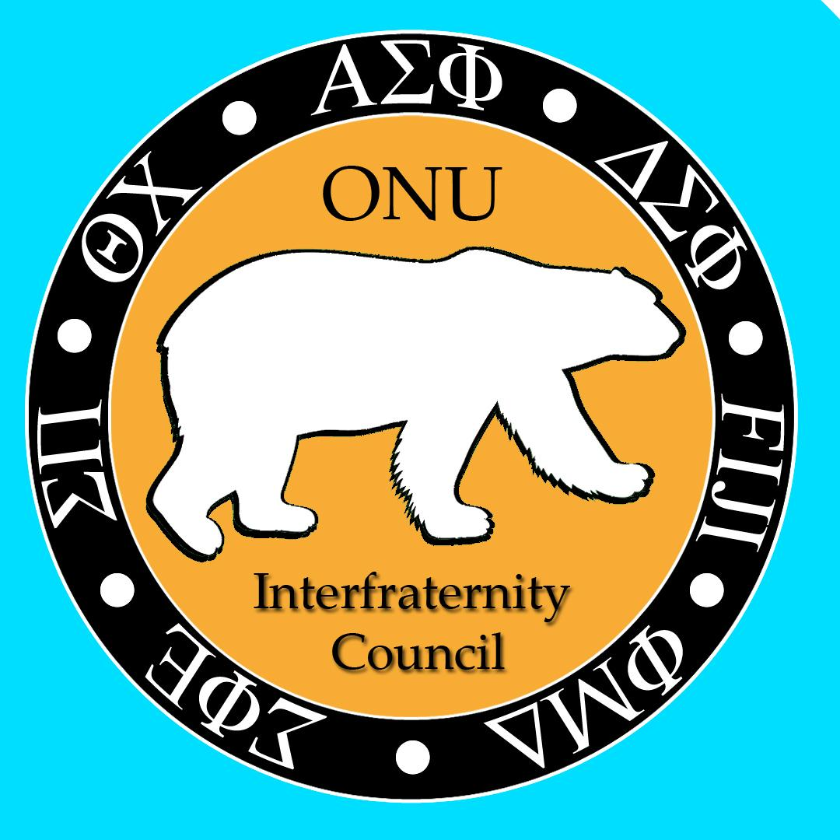
  - Apply for exec
- Vice President of Leadership Development (Brian Pencil)
  - Finalizing Leadership Day details
  - Meeting with Courtney tomorrow
  - Fill out the leadership day interest form!
    - https://forms.gle/RBotaheVf5G48Hds9
- Vice President of Recruitment: (Joe Slusher)
  - Looking ahead for spring recruitment
- Vice President of Risk Management: (Josh Svihovec)
  - Bystander intervention training will be December 2nd
- Vice President of Finance: (Ben Hood)
- IFC dues are needed for Sig Ep, and Fiji
- Refund going to Alpha Sig $14
  - Sig ep
  - Refund for alpha sig
- FIJI has update invoice
- President of Campus and Interfraternal Relations: (Avery Meadows)
  - Ideas for new guy

- Advisor Report:(Jacob Isaacson)
  - Fill the Fireplace
    - Tuesday, December 3, 5:30-7:00pm McIntosh Ballroom
    - Sign-Up Chapter Here

Old Business:
  - Bylaw
    - A reduction of dues will be applied based on Standard of Excellence, this reduction will apply for the following academic school year.
      - Chapters at the gold level will receive five dollars off per brother.
      - Chapters at the silver level will receive three dollars off per brother.
      - Chapters at the bronze level will receive one dollar off per brother.
New Business:

Chapter Reports:
- Alpha Sigma Phi (ΑΣΦ)
  - Moving Volley for the Minds tournament to next semester due to conflicts with other groups
  - Upcoming social with delts and zetas
  - Working on one more dine-to-donate for fall semester
- Delta Sigma Phi (ΔΣΦ)
  - Initiation of our new members this weekend
  - We are having a joint social with alpha sigs and zetas soon

- Phi Gamma Delta (FIJI)
  - Darbara Hull Gala last weekend
  - Social with Alpha Xi this weekend
  - Social with DZ sometime in December
- Phi Mu Delta (ΦΜΔ)
  - Social with Alpha Xi on the 19th
  - Dine to Donate at El Campo on December 10th
  - Trivia Risk Night this Friday at the PMD house
- Sigma Phi Epsilon (ΣΦΕ)
  - Highway cleanup went well
  - Just kicked off Fill the Fireplace
  - Elections will be this Sunday
- Sigma Pi (ΣΠ)
  - Elections on the 17th
  - Brosgiving on the 21st
  - Initiating two new brothers after thanksgiving
- Theta Chi (ϴΧ)
  - Elections this Sunday
  - Highway cleanup last week

Closing Remarks:

Adjournment:
Motioned: ΔΣΦ
Seconded: ΑΣΦ

